**Communications Management Plan Template**

This Communications Management Plan Template is free for you to copy and use on your project

and within your organization. We hope that you find this template useful and

welcome your comments. Public distribution of this document is only permitted

from the Project Management Docs official website at:

[ProjectManagementDocs.com](http://www.projectmanagementdocs.com/)

**Communication Management Plan**

**RAMs Corner: Ticketing Service System**

**Nacor Industries**

**Humabon Place, Magallanes,**

**Makati City 1232**

**Date**

**Table of Contents**

Introduction 3

Communications Management Approach 3

Communications Management Constraints 4

Stakeholder Communication Requirements 5

Roles 6

Project Team Directory 7

Communication Methods and Technologies 8

Communications Matrix 10

Communication Flowchart 11

Guidelines for Meetings 11

Communication Standards 13

Communication Escalation Process 14

Glossary of Communication Terminology 15

# Introduction

The Communication Management Plan (CMP) is an essential tool for ensuring that the Rams Corner Ticketing Service System project is successful. It provides a framework for effective communication between the project team and stakeholders, which is essential for ensuring that the project stays on track and meets its objectives.

Here are some additional details about the CMP:

1. The type of information that will be communicated, such as project updates, progress reports, risks, and issues.
2. The plan outlines the ways we will communicate, such as meetings, emails, phone calls, and web portals, so that everyone stays informed on time.
3. The plan establishes a schedule for project communications, encompassing both formal and informal methods, to regularly update stakeholders and keep them well-informed.
4. The communication management plan designates the project communication responsibility to the person or team assigned as the project's official spokesperson, ensuring they are accountable for conveying project information effectively.
5. The plan delineates the distinct communication requirements of each stakeholder and describes how those needs will be addressed, including considerations for language preferences and accessibility accommodations.
6. The plan specifies the allotted resources, including budget and personnel, to ensure effective and efficient communication.
7. The strategy outlines the procedures for sharing private or important information, including those in charge of permitting the release of the information.
8. The strategy lays forth a framework for managing changes to communication or the communication process, including the procedures for proposing, evaluating, and approving changes. This ensures that all parties are updated on any changes and keeps the communication channel open throughout the project.
9. The project's communication mechanics are depicted in the plan, along with the channels by which team members, stakeholders, and other project participants can exchange information. This helps to ensure that information is shared quickly and effectively and that all stakeholders are kept informed.
10. The strategy identifies any internal or external constraints, such as legal or regulatory requirements, that could affect project communications and provides an approach to deal with them.
11. The project plan specifies the use of standardized templates, forms, or papers to convey project information, such as minutes of the meeting or progress reports. This guarantees that all interested parties receive reliable information.
12. The strategy includes a process for escalating conflicts or communication problems that can come up throughout the project. By doing this, it is ensured that any communication-related problems are quickly addressed and fixed.

In conclusion, the Communications Management Plan is an essential tool for ensuring that the Rams Corner Ticketing Service System project's stakeholders are fully informed, and that communication is effective and efficient.

# Communications Management Approach

As a Project Manager, it is crucial to have an effective communications management approach to ensure smooth project execution and minimize potential problems. Here is an overview of a comprehensive communications management approach:

1. **Clear Project Objectives:**

Make sure that all stakeholders are informed of the project's goals and expectations. In addition to facilitating efficient communication throughout the project lifetime, this clarity helps bring everyone's understanding of the project goals into alignment.

1. **Two-way Communication:**

By cultivating a culture where team members feel comfortable sharing their thoughts, worries, and updates on progress, you can promote open and honest communication. Give stakeholders a chance to voice their opinions and offer forums for discussion.

1. **Regular Reporting:**

Implement a reporting structure that gives all stakeholders regular information on the status, milestones, and hazards of the project. Based on the requirements and preferences of the stakeholders, decide on the reporting schedule and format.

Project managers may encourage effective cooperation, reduce risks, deal with problems quickly, and make sure that project stakeholders are informed and involved throughout the project lifecycle by putting this communications management method into practice.

# Communications Management Constraints

The Rams Corner Ticketing Service System's communications management constraints play a critical role in the detailed project management plan. The limitations and boundaries that may impact the project's communication processes and tactics are established with the help of these constraints. The project team can take proactive steps to address potential difficulties by being aware of and addressing these limits, enabling a smooth flow of information throughout the project.

When implementing The Rams Corner Ticketing Service System, it's important to consider the communications management constraints mentioned.

1. **Time Constraints:**

Time-sensitive deliverables and deadlines are a common feature of projects, which can make communication difficult. The whole flow of communication may be impacted by the limited time available for meetings, decision-making, and delivering feedback.

1. **Language barriers:**

If team members or stakeholders communicate in different languages, there might arise a necessity for translation services or supplementary resources to enable effective communication.

1. **Technology limitations:**

The sorts of communication that can be employed and the population that can be reached may be constrained by the accessibility and capabilities of communication technology. It could be challenging to organize live videoconferences, for instance, if a project team is dispersed across several time zones.

1. **Technical difficulties:**

Problems with network connections, power interruptions, hardware failures can disrupt communication channels, leading to delays or interruptions in transmitting information. This can hinder real-time communication and affect the overall efficiency of communication management.

# Stakeholder Communication Requirements

The Stakeholder Communication Requirements play a vital role in the Rams Corner Ticketing Service System by defining the unique communication needs of stakeholders and the project team. By understanding and addressing the communication requirements of various stakeholders, project teams can ensure that project information is disseminated efficiently, and that stakeholder interests and expectations are properly managed.

Here are some steps to develop a stakeholder communication management plan:

1. **Communication Channels:**

The team should identify the most suitable communication channels and methods for reaching each stakeholder group. This can be achieved by considering a combination of communication tools such as email, meetings, newsletters, website updates, social media, and dedicated customer support lines.

1. **Transparency:**

Establishing transparent and open communication builds trust and credibility among stakeholders as it involves sharing information regarding the project's progress, goals, objectives, and expected outcomes.

1. **Feedback mechanisms:**

Establish channels for stakeholders to provide feedback, ask questions, or raise concerns. This can be in the form of dedicated feedback sessions, surveys, email addresses, or designated contact persons. Ensure that stakeholders have a means to express their opinions and that their feedback is actively solicited and acknowledged.

1. **Document and archive:**

The plan should be a living document that is regularly updated to reflect any changes in stakeholders, objectives, or communication requirements. Share the plan with the project team and stakeholders to ensure alignment and understanding.

# Roles

1. **Class Adviser**

The class adviser serves as a mentor and guide for students, providing advice, encouragement, and support. They may offer guidance on personal and career development, help students navigate challenges, and provide a safe space for students to discuss their concerns.

1. **Project Adviser**

The project adviser assists in the planning phase by providing expertise and advice on project scope, objectives, timelines, and resource allocation. They help the project team identify potential risks and develop strategies to mitigate them.

1. **Stakeholders**

Stakeholders have the responsibility to contribute their input regarding the project's scope, including requirements and expectations. Additionally, they are accountable for accepting the project deliverables as outlined within the project's scope. Maintaining regular communication between the Project Manager and stakeholders is crucial to ensure ongoing alignment of the project with their needs and expectations.

1. **Project Manager**

The role of a project manager is essential in effectively planning, executing, and delivering projects. Project managers are responsible for overseeing the entire project lifecycle and coordinating various aspects to achieve project objectives.

1. **Scrum Master**

The Scrum Master facilitates the Scrum process by organizing and leading various Scrum events, such as daily stand-up meetings, sprint planning sessions, sprint reviews, and sprint retrospectives. They ensure that these events are conducted efficiently and that all team members actively participate.

1. **Scrum Members**

The Scrum Team is responsible for delivering value incrementally and iteratively, working in short timeframes called sprints. The team collectively decides how to accomplish the work, collaborates closely, and shares accountability for the success of the project. The roles within the Scrum Team are complementary, with each role bringing its unique focus and expertise to achieve the project's goals and deliver a high-quality product.

1. **Documentation Manager**

The Documentation Manager has the crucial task of supervising the project documentation to ensure its thoroughness and accuracy. They work closely with the Project Manager and the team to ensure that all project documentation aligns smoothly with the project's scope.

# Project Team Directory

The following table presents contact information for all persons identified in this communications management plan. The email addresses and phone numbers in this table will be used to communicate with these people.

|  |  |  |
| --- | --- | --- |
| **Role** | **Name** | **Email** |
| **Class Adviser** | Jose Eugenio Quesada | [jlquesada@apc.edu.ph](mailto:jlquesada@apc.edu.ph) |
| **Project Adviser** | Alvin C. Limpin | [alvinl@apc.edu.ph](mailto:alvinl@apc.edu.ph) |
| **Stakeholder** | Jose F. Castillo | [jojoc@apc.edu.ph](mailto:jojoc@apc.edu.ph) |
| **Project Manager** | Allan Vincent Nefalar | [aonefalar2@student.apc.edu.ph](mailto:aonefalar2@student.apc.edu.ph) |
| **Scrum Master** | Ruth Morallos | [rrmorallos@student.apc.edu.ph](mailto:rrmorallos@student.apc.edu.ph) |
| **Scrum Members** | Patrick Cortez  Vincent Nacor  Bryan Geneta | [pacortez@student.apc.edu.ph](mailto:pacortez@student.apc.edu.ph)  [vanacor@student.apc.edu.ph](mailto:vanacor@student.apc.edu.ph)  [bdgeneta@student.apc.edu.ph](mailto:bdgeneta@student.apc.edu.ph) |
| **Documentation Manager** | Kieyl Ponce | [kdponce@student.apc.edu.ph](mailto:kdponce@student.apc.edu.ph) |

# Communication Methods and Technologies

A comprehensive grasp of diverse communication methods and technologies is essential for the successful implementation of the Rams Corner Ticketing Service System, enabling effective communication with all stakeholders. It is crucial to consider the capabilities and limitations of each communication method and technology to ensure the timely and efficient dissemination of information. This involves selecting suitable methods for delivering project updates, progress reports, risks, issues, and other pertinent information to stakeholders.

When evaluating the most suitable communication methods and technologies for the Rams Corner Ticketing Service System, the following factors should be taken into consideration:

1. **Cost and Resources**

Assess the cost implications and resource requirements associated with the chosen communication methods and technologies. Consider factors such as equipment, software licenses, maintenance, and training needed for effective implementation.

1. **Time Sensitivity:**

Consider the urgency and time sensitivity of the information being shared. If real-time communication is crucial, options like instant messaging, video conferencing, or collaborative platforms may be more suitable. For less time-sensitive communication, email or project documentation systems may suffice.

1. **Accessibility and Availability:**

Consider the accessibility and availability of the chosen communication methods and technologies for all stakeholders. Ensure that everyone has the necessary tools and resources to participate in the communication process effectively.

1. **Complexity of Information:**

Evaluate the complexity of the information that needs to be communicated. Some concepts may require visual aids, diagrams, or presentations to ensure clarity and understanding. Assess whether the chosen communication methods and technologies can support such visual elements.

Based on these considerations, it is advisable for the Rams Corner Ticketing Service System to employ a blend of communication methods and technologies, which may include:

1. **Meetings:**

Face-to-face meetings, either in person or through video conferencing, are an effective way to facilitate communication among project team members. Meetings can be used for project kick-offs, progress updates, issue resolution, and decision-making.

1. **Video Conferencing:**

Video conferencing tools like Zoom, WebEx, or Microsoft Teams enable remote team members to have virtual face-to-face meetings, discussions, and presentations. Video conferencing helps maintain a personal connection and can be particularly useful for distributed or global teams.

1. **Email:**

Email is accessible to most stakeholders, as it is a common method of communication in professional settings. It can be accessed from various devices, including computers, smartphones, and tablets.

1. **Telephone:**

Utilize telephone calls for direct and prompt communication, especially when engaging with stakeholders in proximity or within the same geographical area.

Effective communication with all stakeholders is vital for the successful implementation of the Rams Corner Ticketing Service System. By considering factors such as cost, time sensitivity, accessibility, and complexity of information, a combination of communication methods and technologies can be utilized, including meetings, video conferencing, email, and telephone calls. This ensures efficient and seamless communication, fostering collaboration and project success.

# Communications Matrix

The following table identifies the communications requirements for this project.

|  |  |  |  |  |  |  |
| --- | --- | --- | --- | --- | --- | --- |
| **Channel** | **From** | **To** | **Type** | **Frequency** | **Format Used** | **Delivery media** |
| Project Planning | Project Manager | Stakeholders | Meeting | Prior to commencing the project | Formal | Email, MS Teams, |
| Release Planning | Project manager, Project team | Stakeholders | Meeting | Revisions will be made as needed before the initiation of the project. | Formal | Email, MS Teams, |
| Sprint Planning | Project manager | Project team | Meeting | Once a week | Informal | Email, MS Teams, |
| Management processes | Project manager, project team | Stakeholders | Artifact | The project will be reviewed and updated as necessary before it begins. | Document | Email, Microsoft 365 |
| Product Backlog | Project manager | Project team | Artifact | Once a week | Document | Microsoft365 |
| Project Update | Project Manager | Project team | Meeting | Once a week | Informal | Email, MS Teams, |

# Communication Flowchart

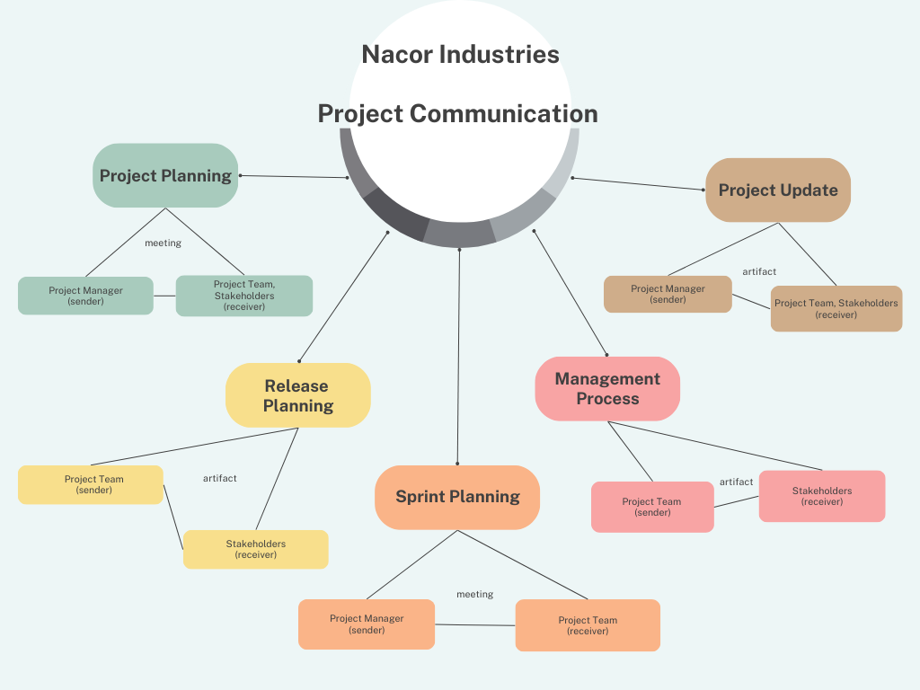

# Guidelines for Meetings

Here are some general guidelines to help you conduct effective and productive meetings for the implementation of the Rams Corner Ticketing Service System:

1. **Objectives**

Determine the specific objectives of each meeting within the context of the project. Is it to provide updates, make decisions, gather feedback, or solve problems? Clearly define the purpose to ensure focused discussions.

1. **Agenda**

It is essential to have a pre-meeting discussion to establish the meeting agenda, including its purpose, discussion topics, and desired outcomes. This enables team members to adequately prepare for the meeting and ensures productive and focused discussions.

1. **Attendance**

Only invite individuals who are essential to achieving the meeting's objectives. Keeping the number of participants reasonable ensures a more focused and efficient discussion.

1. **Discussion**

Ensure that discussions are focused and productive. Keep the conversation on topic and prevent it from devolving into unrelated or lengthy tangents. Use techniques like round-robin style or go-around to ensure everyone has an opportunity to contribute.

1. **Time**

Determine the duration of the meeting and stick to it. Time management is crucial for maintaining participants' engagement and ensuring that discussions do not go off track. Begin the meeting promptly as scheduled, even if some participants are still joining. This encourages punctuality and demonstrates respect for everyone's time.

# Communication Standards

Creating well-defined guidelines and protocols is crucial for facilitating effective and efficient communication within a team and among stakeholders. It is important to foster open channels of communication, allowing team members to freely express their thoughts and ideas. Encouraging active participation and providing opportunities for input from all team members can lead to more collaborative and innovative outcomes. Additionally, it is essential to ensure that the established communication standards are consistently adhered to throughout the entire web application development process. By maintaining clear guidelines and protocols, teams can minimize miscommunication, streamline workflows, and promote successful project outcomes.

Here are some common communication standards that can be established to promote effective communication within a team during web application development:

1. **Responsive Communication:**

Encourage team members to respond promptly to messages and requests, ensuring that communication is timely and avoids unnecessary delays.

1. **Regular Project Updates:**

Set expectations for regular project updates, such as status reports or progress meetings, to keep all stakeholders informed about the project's progress, milestones, and any potential challenges.

1. **Active Listening:**

Promote active listening skills among team members, encouraging them to attentively listen to others, ask questions for clarification, and paraphrase to ensure understanding.

1. **Collaboration:**

Encourage collaborative communication practices, such as sharing ideas, soliciting input from team members, and fostering a supportive environment that values teamwork.

1. **Documentation:**

Emphasize the importance of documenting key decisions, discussions, and actions taken during the project. This ensures transparency, facilitates knowledge sharing, and serves as a reference for future communication.

1. **Feedback:**

Encourage regular feedback and provide opportunities for team members to share their thoughts and suggestions on improving communication processes. Foster a culture of continuous improvement to enhance communication practices over time.

Remember that these standards can be tailored to fit the specific needs and dynamics for the development team.

# Communication Escalation Process

When establishing a communication escalation process for the Rams Corner Ticketing Service System, it's important to have a clear and documented procedure that outlines the steps and guidelines for escalating issues when resolution cannot be achieved within the project team. Here is a general framework for a communication escalation process:

1. **Identify the Issue:**

The first step is to clearly identify the issue or complication that has arisen in project communications. This could be a breakdown in communication, unresolved conflicts, stakeholder disagreements, or any other communication-related problem.

1. **Review Documentation:**

Collect all relevant documentation, communication records, and any other evidence related to the issue. This will provide a clear understanding of the problem and help in the escalation process.

1. **Define Communication Channels:**

The development team must determine and establish the main methods of communication to be utilized for their project, such as email, project management software, or specific communication tools. It is essential for every team member to be knowledgeable about and could utilize these communication channels.

1. **Escalation Criteria:**

Define specific criteria that determine when an issue should be escalated. For example, if the issue has been ongoing for a certain period, or if it involves key stakeholders and significantly impacts project progress or objectives.

1. **Identify Escalation Points:**

Determine who should be involved in the escalation process. This may include project managers, senior management, or specific stakeholders depending on the nature of the issue. Clearly identify the roles and responsibilities of each escalation point.

# Glossary of Communication Terminology

|  |  |
| --- | --- |
|  |  |
| Communication Management Plan (CMP) | A plan that outlines the strategies, methods, and channels for effective communication between the project team and stakeholders. |
| Stakeholders | Individuals or groups who have an interest or are affected by the project, including project managers, team members, clients, and users. |
| Communication Channels | The various methods and tools used to convey information, such as meetings, emails, phone calls, and web portals. |
| Formal Communication | Planned and structured communication that follows established procedures and protocols. |
| Informal Communication | Spontaneous and unplanned communication that occurs in a casual manner |
| Internal Constraints | Limitations and factors within the project team or organization that may impact communication, such as legal or regulatory requirements. |
| External Constraints | Limitations and factors outside the project team or organization that may impact communication, such as government regulations or industry standards. |
| Escalation | The process of raising and addressing conflicts or communication problems that arise during the project. |
| Scrum Master | The specific methods and channels by which information is exchanged among team members and stakeholders. |
| Documentation Manager | The person responsible for overseeing the project documentation to ensure its accuracy and completeness. |
| Communication Matrix | A table that outlines the communication requirements, channels, and frequency for different aspects of the project. |
| Guidelines for Meetings | Recommendations for conducting effective and productive meetings, including defining objectives, preparing an agenda, managing attendance, and facilitating focused discussions. |
| Communication Standards | Established guidelines and protocols for communication within a team, ensuring responsive communication, regular updates, and adherence to established procedures. |
| Communication Mechanics | The specific methods and channels by which information is exchanged among team members and stakeholders. |

Sponsor Acceptance

Approved by the Project Sponsor:

Date:

<Project Sponsor>

<Project Sponsor Title>

This free Project Communications Management Plan Template is brought to you by [www.ProjectManagementDocs.com](http://www.ProjectManagementDocs.com)